
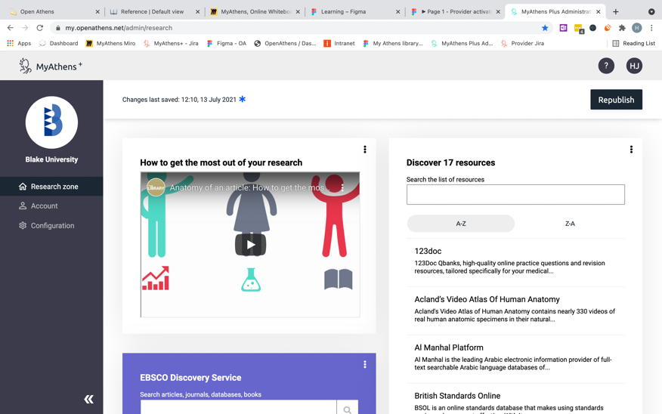
MyAthens is a simple and easy way of accessing online resources and finding information about your library.

Why use MyAthens?

MyAthens is the quickest way to gain access to the full range of e-resources held by our library, including custom content to help your research. Sign in once to MyAthens and be automatically signed in to all resources you have access to – no more access denied messages!
Key features

- Resource list
- Curated content
- Library information
- Mobile friendly
Any questions? Contact your library administrator

Sue Jones

Sue@library.ac.uk
How to access MyAthens

Go to my.openathens.net
and use your library log in details.

